The check statement allows us to terminate loop pass, just like the continue statement does.

But it allows us to check certain conditions. We can use some sort of logic. So, when we define our check statements and define the logic, if the condition is not true, any remaining statements in our current statement block.

After the check statements will be ignored and the next loop pass will start, just as it did with the continue statements. The check statement is a little bit like a combination of the if statements and continue statement we used in the last exercise.

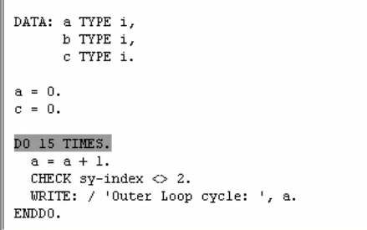

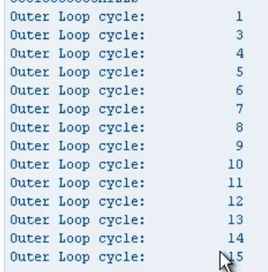

don't be surprised to see the check statement outside of loops like the do loop or the while loop. Because the check statements only terminate an individual loop run, called loop pass, but it can also be used to check other processing blocks, like subroutines or events. And a check statement is executed, it all depends at what level in your program it is being executed. If our check statement was outside of this loop, then it would terminate our program. If it was inside another processing block, maybe the app screen selection processing log. Or they would terminate that block of code.

